VIEW OPTIMIZING :

SQL Server Execution Times:

CPU time = 0 ms, elapsed time = 139 ms.

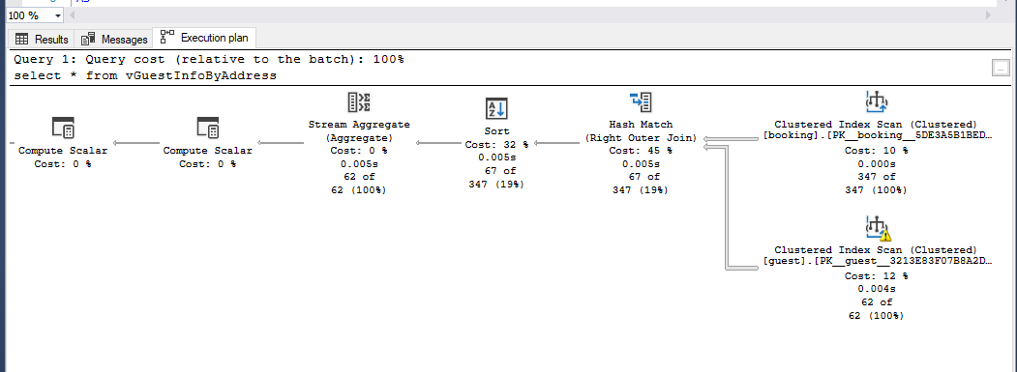Looking at the execution plan, I notice that the clustered index scan is used to scan both booking and guest table , and cost only 10 and 12% , respectively. In booking table , SQL do the scan 347 rows and return 347 rows which is quite effectively.

For guest table, number of rows read is 649 and return 62 rows is not too bad for only 12% cost.

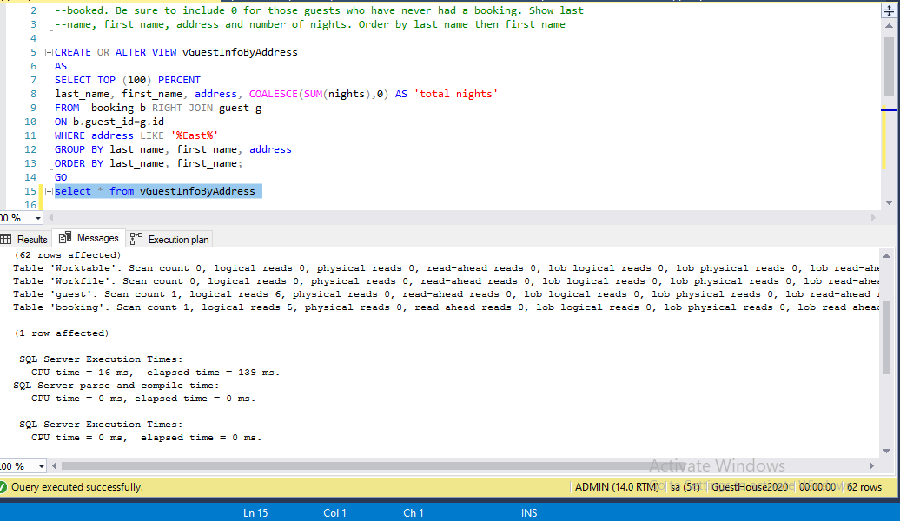I would say that this view is efficient and don’t need to have more optimization.

